**C CODE VULNERABILITIES**

**3.2: Task 1: Shellcode Practice**

*Question 1.*

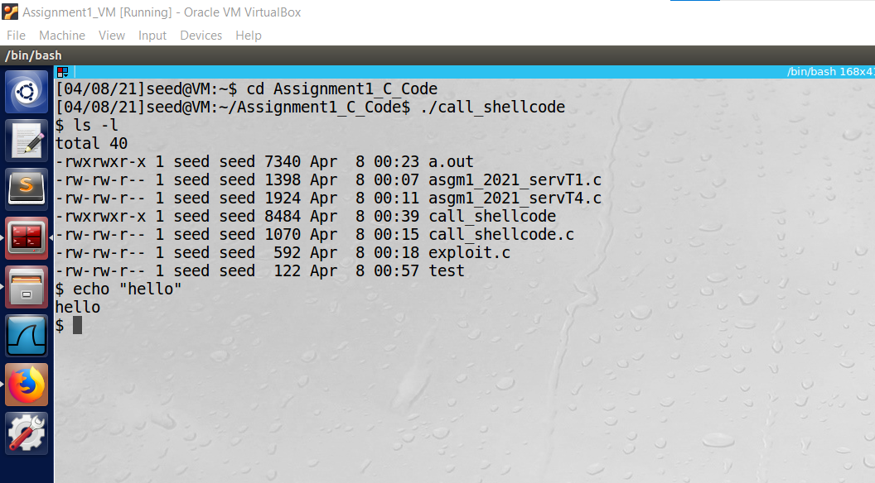

Figure 1 Executing the shellcode program

After compiling and executing the code, it opens a shell which allows us to enter and execute code as seen above. This is because he computer is being fed machine code that is a decompiled program that launches a shell. It is essentially forcing the computer to execute the shell by giving it meachine language commands.

**3.3 The Vulnerable Program**

*Question 2.*

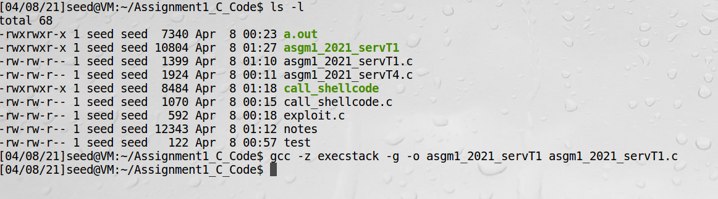

Figure 2 Successfully compiling the vulnerable program

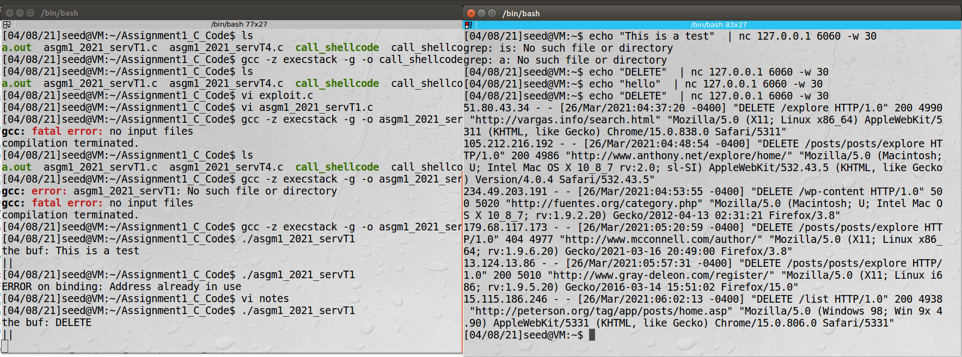

Figure 3 Successfully searching for the term “DELETE” using the client (right side) and receiving a meaningful results on the client screen.

**3.4 Exploiting the Vulnerability**

**3.4.1 Task 2**

*Question 3*

**Demonstration Video:**

<https://pro.panopto.com/Panopto/Pages/Viewer.aspx?tid=542e864d-9120-430b-a119-ad1a004307e6>

The vulnerability of the program exists in the exec_command function. Specifically the vulnerability is in the sprintf() command and the fact that the input from the user is directly copied to the command variable, which is then executed in the system() command. This allows the user to enter their own commands for the system to execute such as an open file command. Therefore, all the attacker must do is enter something like “; sudo vim /etc/shadow” and the shadow file will open on the client terminal. This is called a command injection attack.

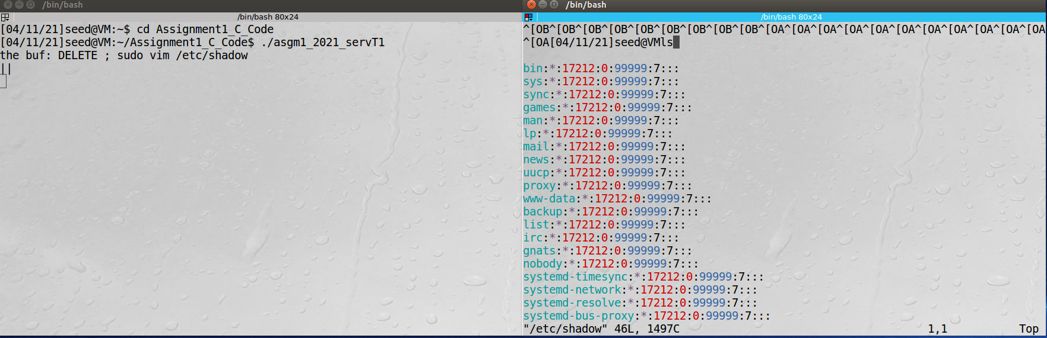

Figure Shadow file displayed on the client terminal window (right)

**3.4.2 Task 3**

*Question 4*

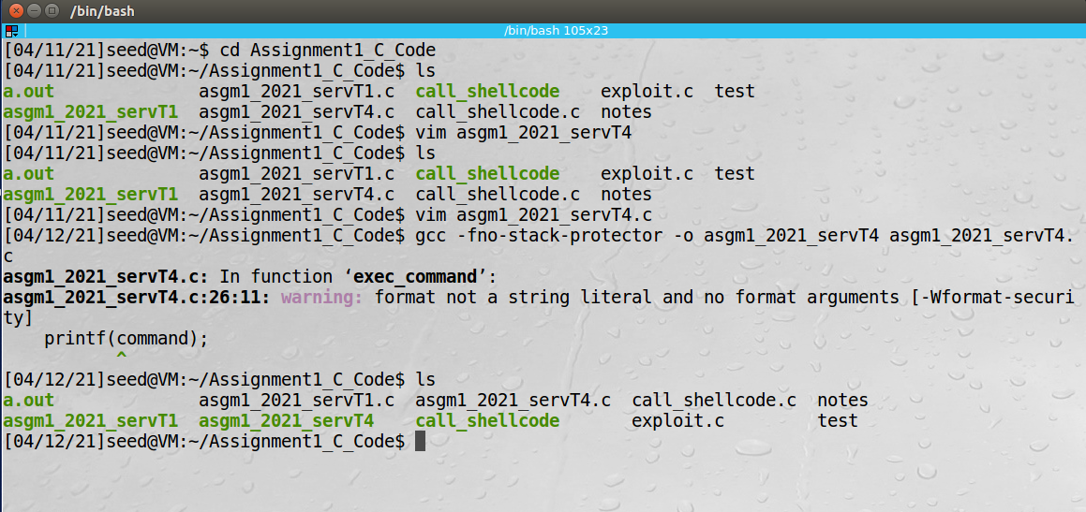

Figure 5 New program successfully compiled

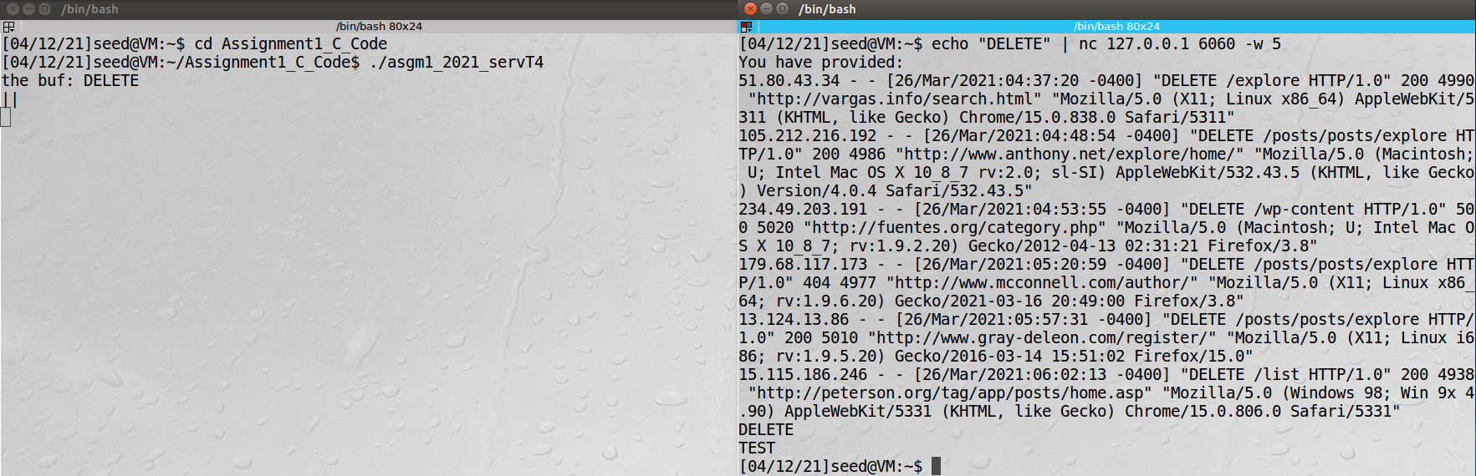

Figure Fixed code successful execution, server (left), client (right)

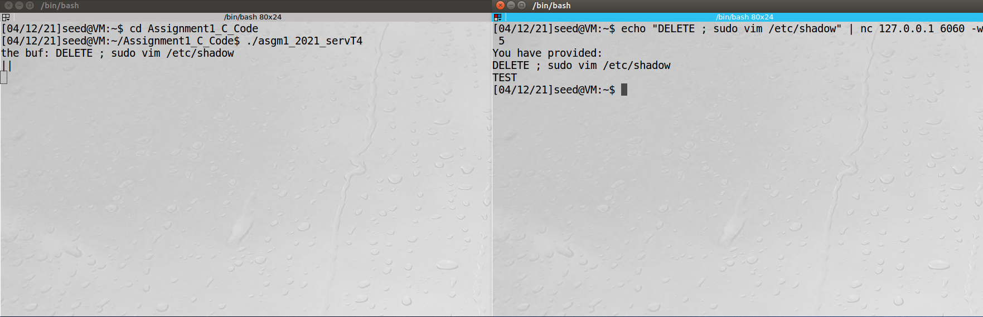

Figure Unsuccessful command injection attack in recompiled code. Server (left), client (right).

The command injection attack does not work due to the implementation of secure coding practices. Specifically, sanitization and canonicalization to remove any unwanted characters in the input and stop the command injection. The new program separates the different elements of the system command into separate string elements, so they can put together by the program instead of manipulated by the client.

**3.4.3 Task 4**

*Question 5*

**Demonstration Videos:**

Debugging:

<https://pro.panopto.com/Panopto/Pages/Viewer.aspx?tid=a292cb4c-603f-42ce-8170-ad190009496f>

Exploit.c contents:

<https://pro.panopto.com/Panopto/Pages/Viewer.aspx?tid=654aa1ab-a3b6-455b-b6ea-ad1900098210>

Successful attack:

<https://pro.panopto.com/Panopto/Pages/Viewer.aspx?tid=75b261f0-0eac-4400-a702-ad1900076432>

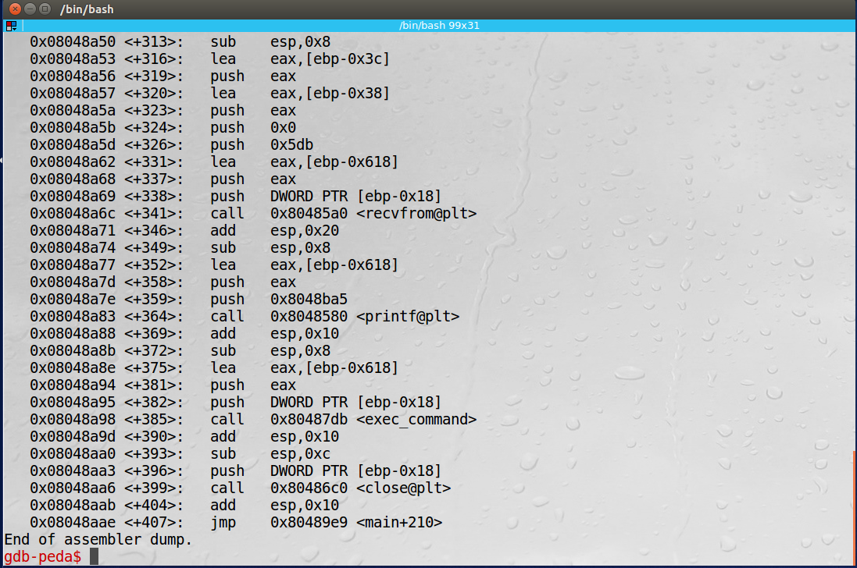

Figure 8 Return address after exec_command has been executed

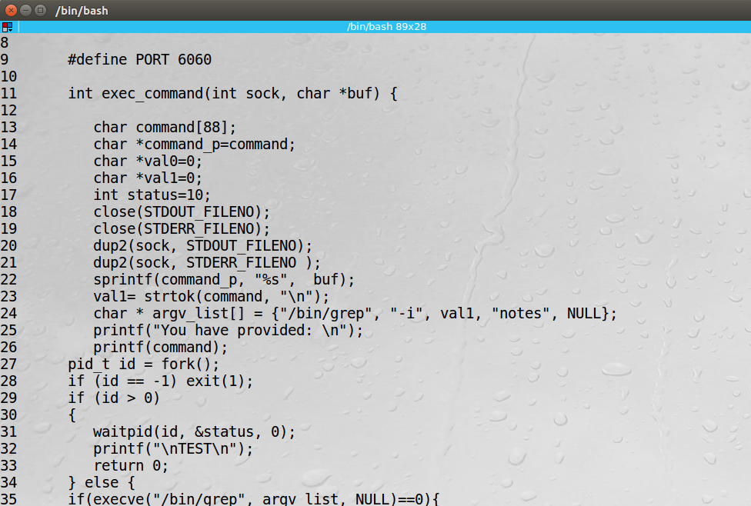

Figure 9 locating security flaw in vulnerable program, a breakpoint must be placed at line 26

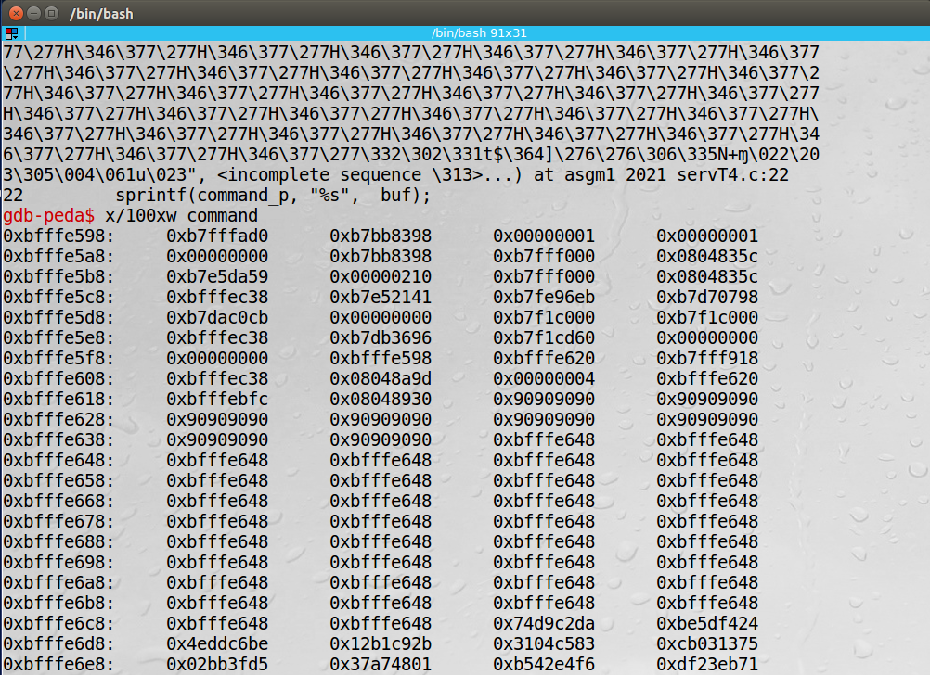

Figure 10 Return address found by printing out memory content starting from command variable in GDB at breakpoint at line 26

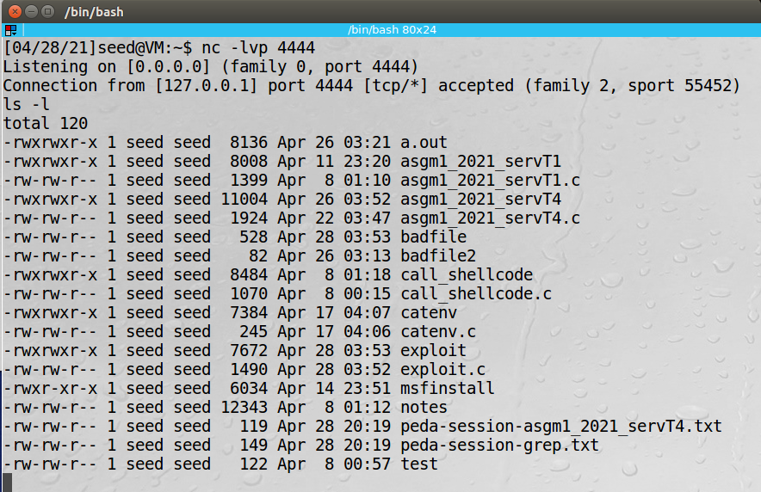

Figure successful reverse shell injection

**3.4.4 Task 5**

*Question 6*

**Demonstration Videos:**

Format String Vulnerability:

<https://pro.panopto.com/Panopto/Pages/Viewer.aspx?tid=ddf27625-26d4-49c4-b8c7-ad1a0059feab>

I was not able to get the rest of question 6 to work.

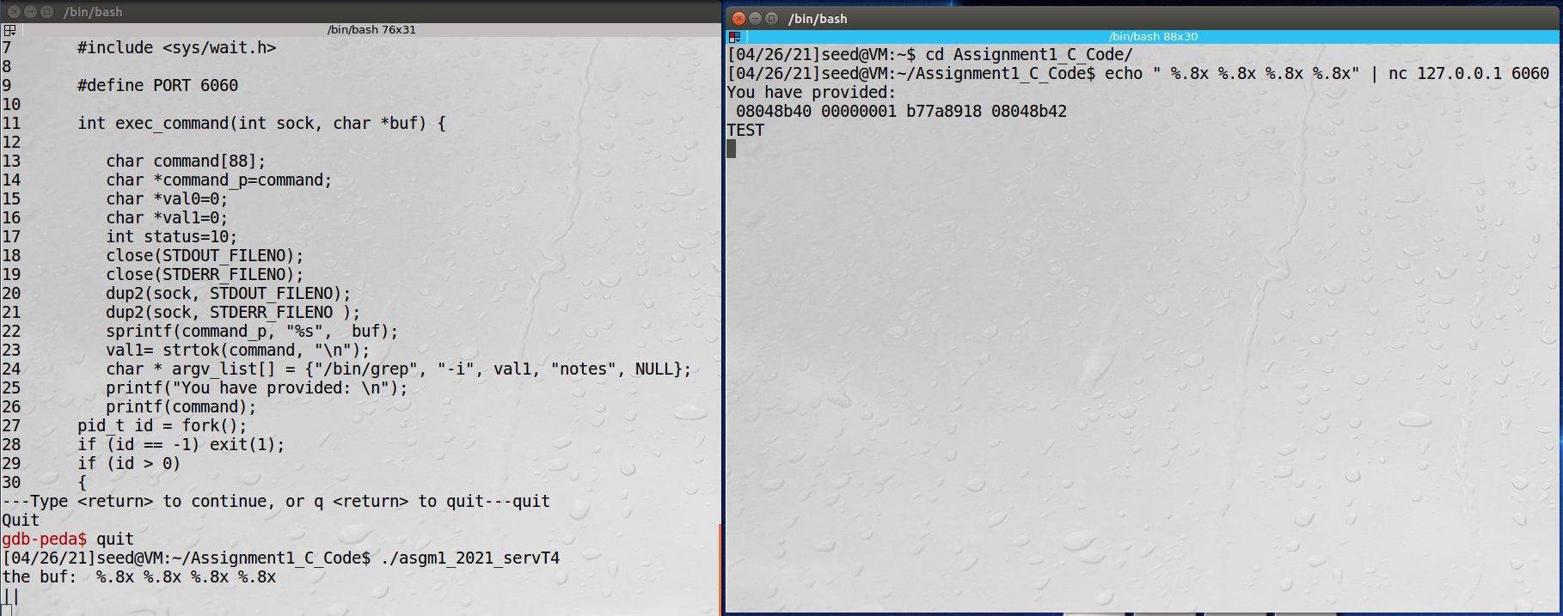

Figure 12 Identifying the format string vulnerability to print out memory contents from the vulnerable program.

**PROVIDING SECURE CODE IN JAVA PROGRAMS**

*Question 7*

Java code walkthrough:

<https://pro.panopto.com/Panopto/Pages/Viewer.aspx?tid=c596e65b-d4c1-4887-a82d-ad1900cbb02e>

Java code execution:

<https://pro.panopto.com/Panopto/Pages/Viewer.aspx?tid=55006a31-89a3-4fc0-a798-ad1900cbe773>